**Changing Brushes in a Denso Alternator**

Author [Sparky](http://sparkys-answers.com/author/steven-head)Posted on [October 19, 2010](http://sparkys-answers.com/2010/10/changing-brushes-in-denso-alternator.html)Tags [Alternator](http://sparkys-answers.com/tag/alternator), [Brush Replacement](http://sparkys-answers.com/tag/brush-replacement), [Charging System](http://sparkys-answers.com/tag/charging-system), [Denso](http://sparkys-answers.com/tag/denso), [Denso Alternator](http://sparkys-answers.com/tag/denso-alternator)

To check and change the brush holder assembly on a Denso internal fan alternator, start by removing the nut on the insulator post. Then with the insulator removed proceed to removing the remaining nuts, one screw and ground strap. The extra screw and ground strap will not always be present. Note that this particular alternator is off of a Chrysler, Dodge, Jeep or Plymouth vehicle and does not have a built in voltage regulator. Most Denso alternator of this style do have a built in voltage regulator and there will be a round, oval or T shaped socket for a harness to plug into. The brush holder replacement procedure is the same except that this particular brush holder uses three attaching screws where all others only use two.

[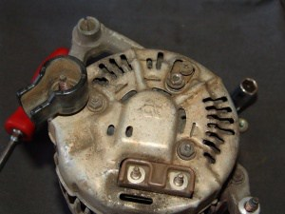](http://i2.wp.com/104.197.77.209/wp-content/uploads/2010/10/DSC04238.jpg)

Using a screw driver or other device, lift the tin cover from the back of the alternator assembly. This will expose the brush holder along with the rectifier and regulator if equipped.

[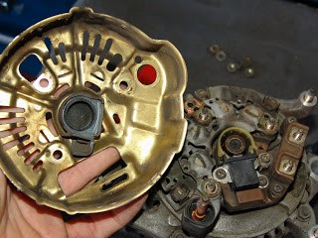](http://i1.wp.com/sparkys-answers.com/wp-content/uploads/2010/10/DSC04237.jpg)

Remove the screws that hold the brush holder in place. Most of these alternators only have two screws. However this one uses three. Some times these screws can be difficult to loosen and the screws can easily be damaged. Make sure you use a good #2 phillips head screw driver and use a firm grip.

In the picture below you can clearly see the worn brushes. I am holding it it upside down to show the more worn brush.

[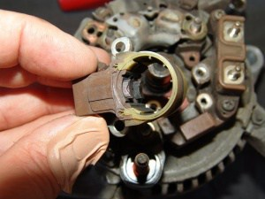](http://i0.wp.com/104.197.77.209/wp-content/uploads/2010/10/DSC04230.jpg)

Inspect the slip ring for excessive wear. The copper slip rings can be worn so thin that the plastic underneath will be exposed. If this happens you may want to consider a replacement alternator. Oil on the brushes or slip rings will rapidly accelerate slip ring wear. So please make sure all oil leaks are repaired. If you have an ohmmeter it would be advisable to check the resistance across the two slip rings and compare it to factory specifications. In most cases it will be between 2 and 3 ohms.

[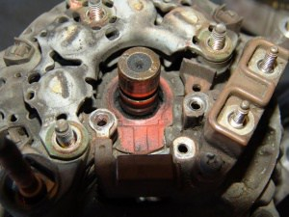](http://i1.wp.com/104.197.77.209/wp-content/uploads/2010/10/DSC04231.jpg)

The new brush holder ready to install.

[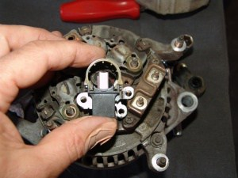](http://i2.wp.com/104.197.77.209/wp-content/uploads/2010/10/DSC04232.jpg)

Using a small screwdriver push the brushes back into the brush holder and slide the assembly into place.

[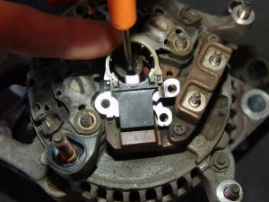](http://i1.wp.com/104.197.77.209/wp-content/uploads/2010/10/DSC04233.jpg)

Start on screw and then wiggle the brush holder as needed to line up the remaining holes.

[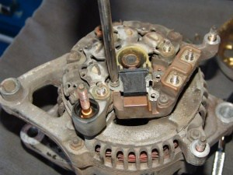](http://i2.wp.com/104.197.77.209/wp-content/uploads/2010/10/DSC04235.jpg)

Install the remaining screws and tighten the brush holder assembly down.

[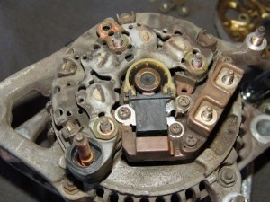](http://i1.wp.com/104.197.77.209/wp-content/uploads/2010/10/DSC04236.jpg)

Install the rear cover and the repair is done. If possible test the alternator before reinstalling it.

Need to order a brush holder for your Denso alternator, [click here.](http://store.the-electric-connection.com/brush-holders-c154.aspx)

[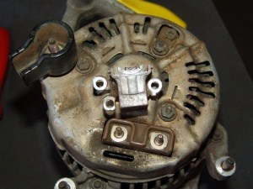](http://i1.wp.com/104.197.77.209/wp-content/uploads/2010/10/DSC04239.jpg)